**Adaptations Of Herbivorous Insects and Their Natural Enemies to Fluctuations In The Environment Within The Bioenergy Crop Miscanthus X Giganteus.**

1. **Background**

Ecological relationships within agricultural fields are in constant flux, varying over space and changing in time and several studies document arthropods associated with various biofuel crops such as Miscanthus X Giganteus (Coffin et al., 2021). Individual organisms live together in an ecosystem and depend on one another, and it is paramount to understand the interactions amongst different microorganisms living in the same habitat and get how they relate with their environment and hence influence crop production. NDVI has been used in a variety of temperate and tropical ecosystems to identify insect infestations (Jepsen *et al.,* 2009). The main objectives of this study were to investigate the following hypotheses: (*i)* Do average wind speed, average air temperature, average relative humidity and average precipitation have an influence on NDVI values across the six field excursions in 2015 and 2016. (*ii*) There is a significant positive correlation between the abundance of spiders in the field and the abundance of Orius. (*iii)* Increase in NDVI has an effect on the total number of aphids in the field.

**2.0 Methods**

The relationships between the four meteorological variables (average wind speed, average air temperature, average relative humidity and average precipitation) and NDVI was analysed by multiple linear regression in R. The first thing was to plot the data to see what they looked like. Histograms were used to conduct exploratory analysis of the meteorological variables and NDVI this was done to Identify Patterns by looking at the shape of the histograms, we were able gain insights into the underlying distribution model of the data to see whether it was gaussian, exponential or bimodal. The data were also visualised on combined scatterplot. Finally, a multiple linear regression model was fitted, and results were plotted. To investigate whether there was a demonstrable association between the abundance of spiders in the field and Orius a Pearson’s correlation was used. Data were explored by plotting total spider count against Orius on a scatter plot hence the linearity assumption was fairly met for Pearson’s correlation. To test if Increase in NDVI has an effect on the total number of aphids in the field Quasi-Poisson GLM model was used. The first thing was to plot the data to see what they look like on a scatter plot with a smooth curve. Then a Quasi-Poisson linear model was fitted and to assess statistical significance ANOVA was used.

**3.0 Results**

Multiple Linear Regression

1. Do average wind speed, average air temperature, average relative humidity and average precipitation have an influence on NDVI values across the six field excursions in 2015 and 2016.

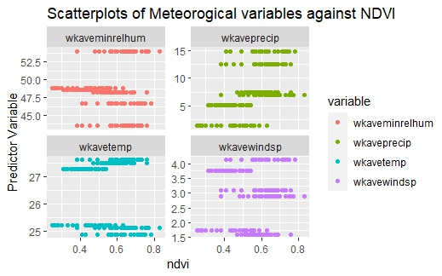

Figure 1. Scatterplots of meteorological variables against NDVI. The figure shows trends between each of the meteorological variable that was fitted in the multiple linear regression model against NDVI. The plot reveals trends in the data, helping us to identify different types of relationships among variables. Of which the observed trends are mostly linear relationships between the predictor variables and the outcome variable hence meeting the assumptions of multiple linear regression.

The regression model was found to be statistically significant, with an F-statistic of 73.39 and a p-value less than 2.2e-16, indicating that the overall regression model explains a significant amount of the variability in the outcome variable. The results show wkavewindsp, wkaveminrelhum, and wkaveprecip are statistically significant predictors of ndvi, with p-values less than 0.05. However, wkavetemp was found to be not statistically significant in predicting ndvi, with a p-value greater than 0.05. Thus, we fail to reject the null hypothesis for wkavetemp, indicating that it does not have a significant linear relationship with ndvi in this model.

Correlation

1. There is a significant positive correlation between the abundance of spiders in the field and the abundance of Orius.

Figure 2. Scatterplot of total count of Spiders against total count of Orius. The Plot shows a positive correlation indicating that as one variable increases, the other increases too. This means Pearson’s correlation is appropriate since the two numeric variables follow a ‘straight-line’ relationship.

Upon fitting the model, the correlation coefficient is 0.1675904 and the p-value is = 0.01023, this indicates a positive correlation between the variables. The p-value is less than 0.05, which indicates that the correlation coefficient is significantly different from zero. Therefore, we can reject the null hypothesis that there is no correlation between the variables. The correlation is statistically significant.

# Poisson GLM

1. Increase on NDVI has an effect on the total number of aphids in the field.

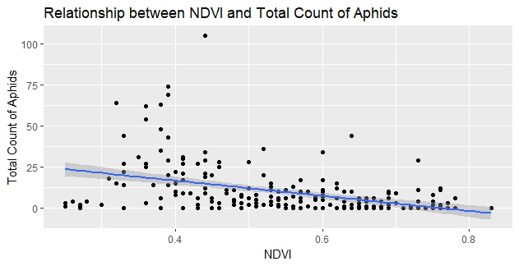

Figure 3. Scatterplot of NDVI against total count of Aphids. The graph indicates a negative linear relationship, it indicates that as one variable increases, the other decreases.

Figure 4. Scatterplot of NDVI against total count of Aphids. The graph indicates a negative linear relationship, this graph uses a smooth curve to show the trends in the data, it indicates that as one variable increases, the other decreases.

When the Quasi-Poisson regression model was fitted to examine the effect of NDVI on the total number of Aphids in the field, the coefficient for NDVI was significantly negative (estimate = -4.90050, SE = 0.6325, t = -7.747, p < 0.00001), indicating a reduction in the number of aphids with increasing NDVI values. The model, with an intercept of 4.7300 (SE = 0.3045, t = 15.533, p = 2e-16), showed a dispersion parameter of 15.12188, a null deviance of 3837.4 on 233 degrees of freedom, and a residual deviance of 2880.6 on 232 degrees of freedom.

**4.0 Conclusions**

Meteorological variables predicted NDVI, *R*2 = 0.5618, *F* (4,229) = 73.39, *p* < 2.2e-16. We found a strong correlation between total count of Orius and Spiders, *r* (232) =0.1675904, *p* = 0.01023. In a Quasi-Poisson regression model examining the effect of NDVI on the total number of aphids in the field, the coefficient for NDVI was significantly negative (estimate = -4.90050, SE = 0.6325, t = -7.747, p < 0.00001), indicating a reduction in the number of aphids with increasing NDVI values.

**5.0 References**

Coffin, AW. *et al*. (2021). Responses to environmental variability by herbivorous insects and their natural enemies within a bioenergy crop, Miscanthus x giganteus. PLoS One. doi: 10.1371/journal.pone.0246855.

Jepsen, J.U. *et al*. (2009). Monitoring the spatio-temporal dynamics of geometrid moth outbreaks in birch forest using MODIS-NDVI data Remote Sens. Environ. v113 issue 9 issn 0034-4257 10.1016/j.rse.2009.05.006